Project Design Phase-II
Technology Stack (Architecture & Stack)

Date | 05 July 2026
Project Name | Cab booking
Maximum Marks | 4 Marks

Technical Architecture:
The Deliverable shall include the architectural diagram as below and the information as per the table1 & table 2
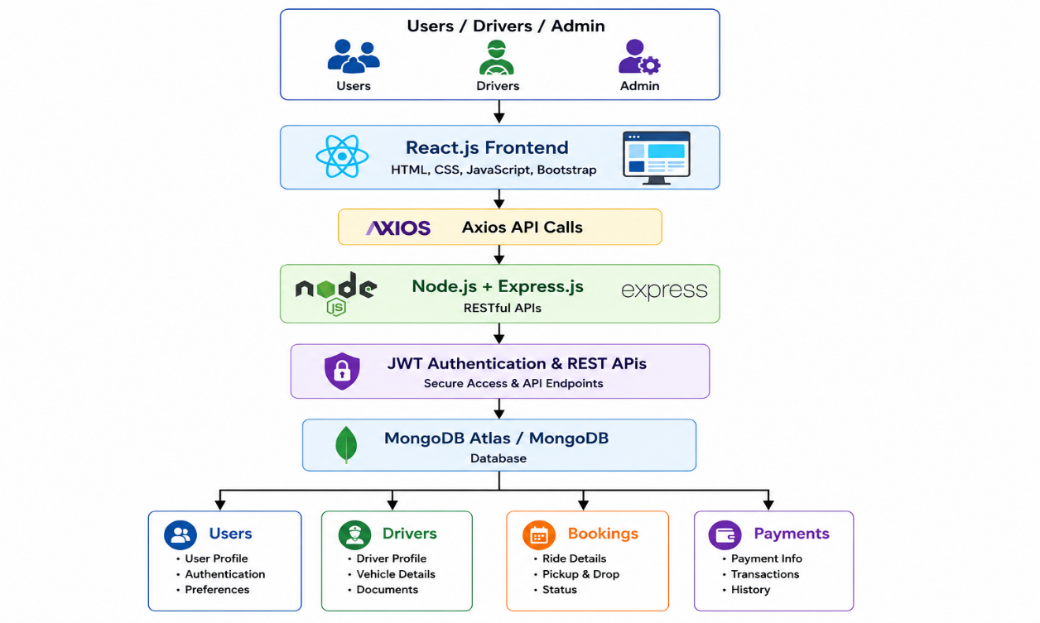

Table-1 : Components & Technologies:
S.No | Component | Description | Technology
1 | User Interface | Web application for Users, Drivers, and Admin | React.js, HTML5, CSS3, Bootstrap
2 | Application Logic-1 | User authentication and authorization | Node.js, Express.js, JWT
3 | Application Logic-2 | Cab booking and ride management | Express.js, REST APIs
4 | Application Logic-3 | Fare estimation, booking history, payment handling | Node.js
5 | Database | Store users, drivers, bookings, and payments | MongoDB, Mongoose
6 | File Storage | Store profile images and documents | Local Storage / Cloudinary (optional)
7 | External API-1 | Location and Maps | Google Maps API
8 | External API-2 | Online Payment | Razorpay / Stripe
9 | Infrastructure | Application hosting and deployment | Local Server / Render / Vercel

Table-2: Application Characteristics:
S.No | Characteristic | Description | Technology
1 | Open-Source Frameworks | Frameworks used for frontend and backend development | React.js, Express.js, Node.js, Bootstrap
2 | Security Implementations | Secure authentication and password protection | JWT, bcryptjs, HTTPS
3 | Scalable Architecture | Three-tier MERN architecture supporting future expansion | MERN Stack (React, Node.js, Express.js, MongoDB)
4 | Availability | Application accessible anytime with reliable backend | Render / Vercel / MongoDB Atlas
5 | Performance | Fast API responses and optimized database queries | Axios, Mongoose, MongoDB Indexing

